Chapter 12, Solution 1.

- If 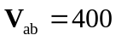, then
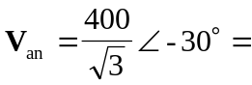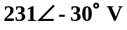
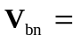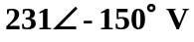
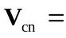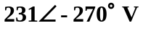

- For the acb sequence,
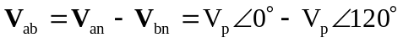
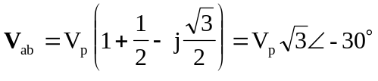

i.e. in the acb sequence, 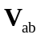 lags 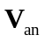 by 30.

Hence, if , then
